**Practical 4**

**Designing and configuring a network topology**

**Aim:** Configure IP static routing

**Theory:**

1. Static routing method is most trusted by a router.
2. Static routing is not really a routing protocol.
3. Static routes do not dynamically adapt to network changes, are not particularly scalable, and require manual updating to reflect changes.

Static routing has the following advantages

1. There is no bandwidth usage between routers, which means you could possibly save money on WAN links.
2. There is no overhead on the router CPU, which means you could possibly buy a cheaper router than you would use if you were using dynamic routing.
3. It adds security because the administrator can choose to allow routing access to certain networks only.

Static routing has the following disadvantages

1. Static routes don’t dynamically adapt to network change.
2. If a network is added to the internetwork, the administrator has to add a route to it on all routers—by hand.
3. It’s not feasible in large networks because maintaining it would be a full- time job in itself.
4. With static routing, as your network grows, it can be difficult just keep adding static routes makes sure everybody can still get everything.
5. The administrator must really understand the internetwork and how each router is connected in order to configure routes correctly.

**There are two different styles to configure an “ip route” command:**

1. Using a next hop IP address
2. Using an outgoing interface

Consider the following network topology

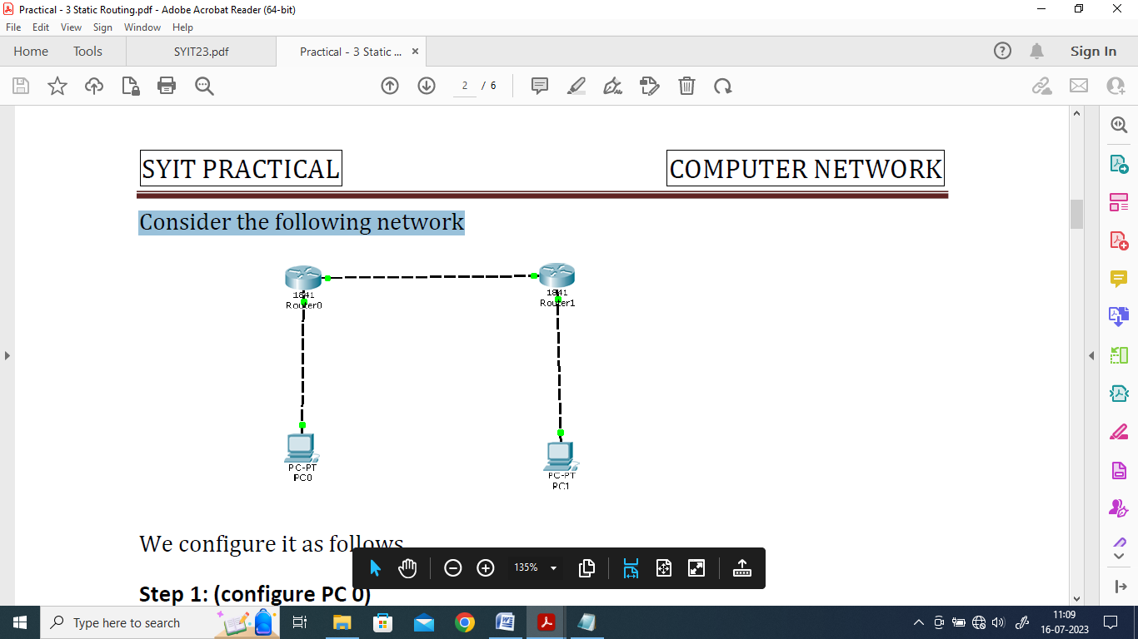

We use the following IP addresses for hosts and Routers

|  | Interface | IP address | Subnet Mask | Gateway |
| --- | --- | --- | --- | --- |
| PC0 |  | 10.0.0.2 | 255.0.0.0 | 10.0.0.1 |
| PC1 | 30.0.0.2 | 30.0.0.1 |
| Router 0 | FastEthernet 0/0 | 10.0.0.1 |  |
|  | FastEthernet 0/1 | 20.0.0.1 |
| Router 1 | FastEthernet 0/0 | 20.0.0.2 |
|  | FastEthernet 0/1 | 30.0.0.1 |

We configure the given topology using Cisco Packet tracer as follows

Step 1: Configuring PC 0

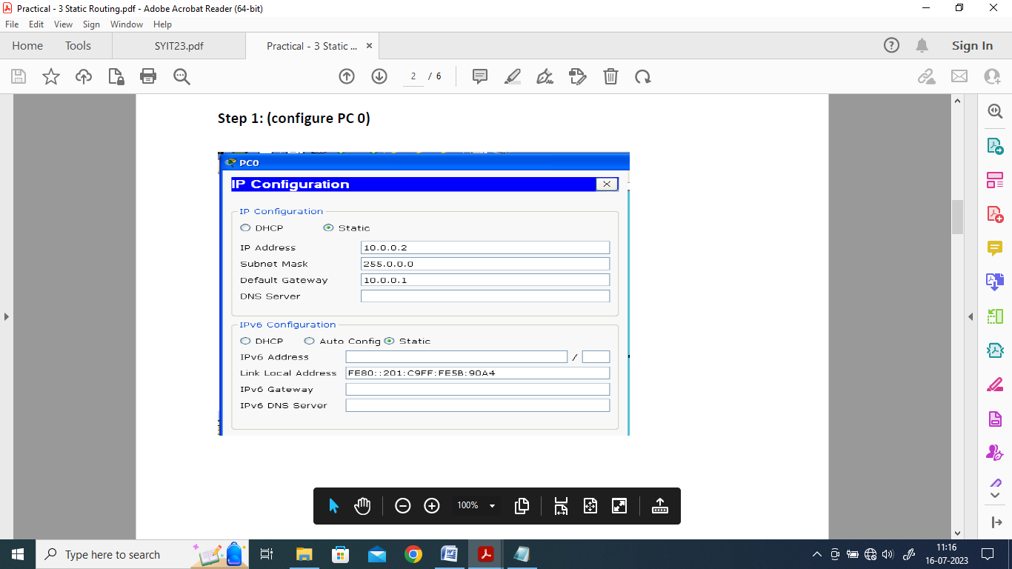

Step 2: Configuring PC 1

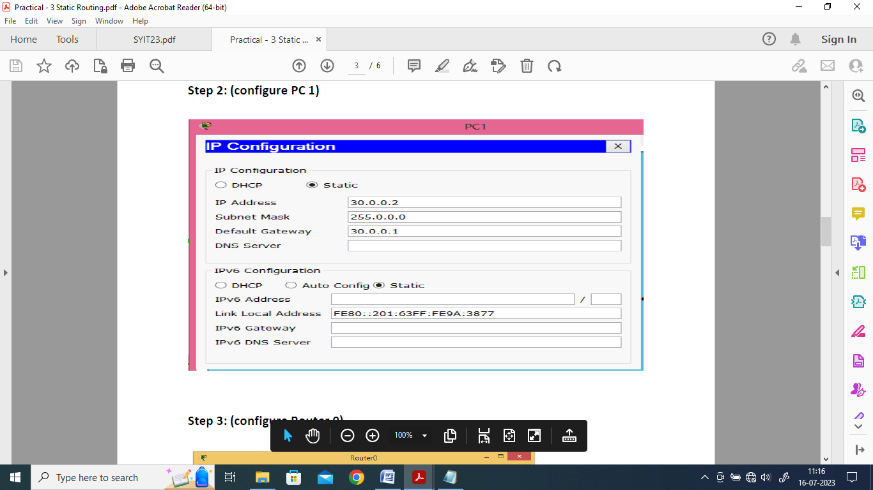

Step 3: Configuring Router 0

Interface: FastEthernet0/1

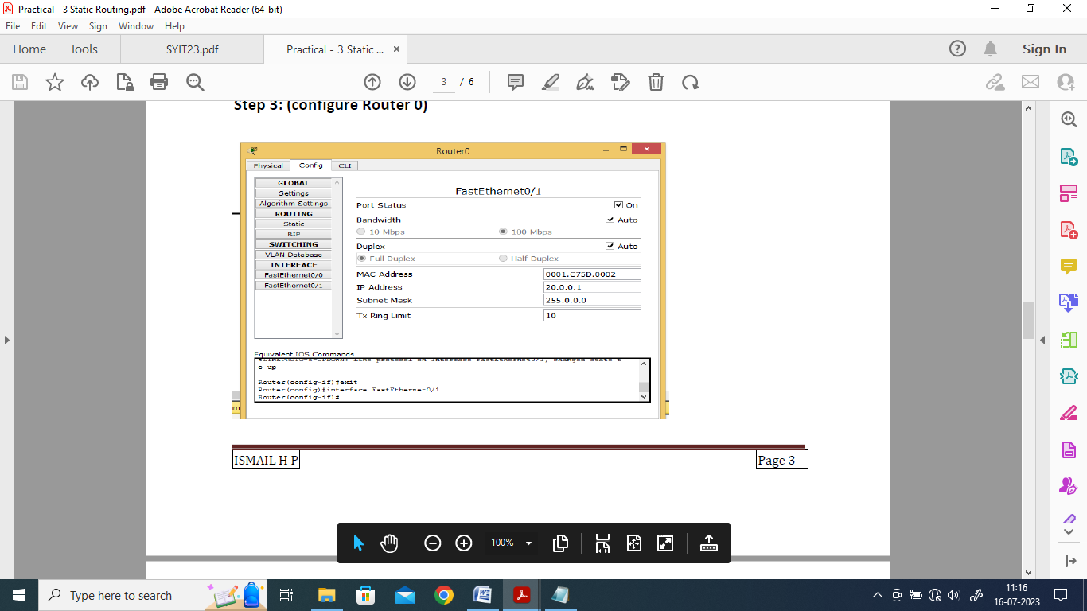

Interface: FastEthernet0/0

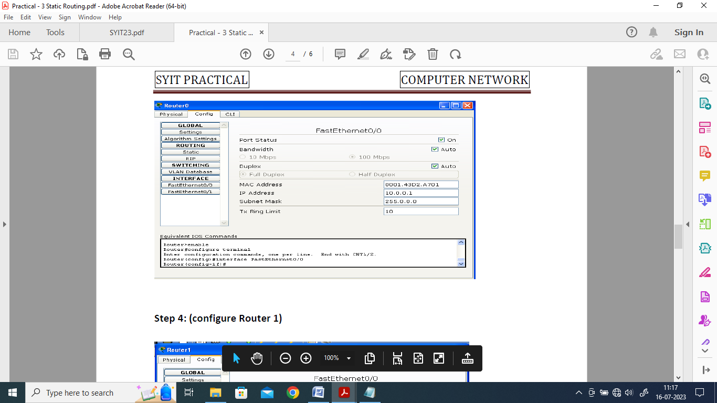

Step 4: Configure Router 1

Interface: FastEthernet0/0

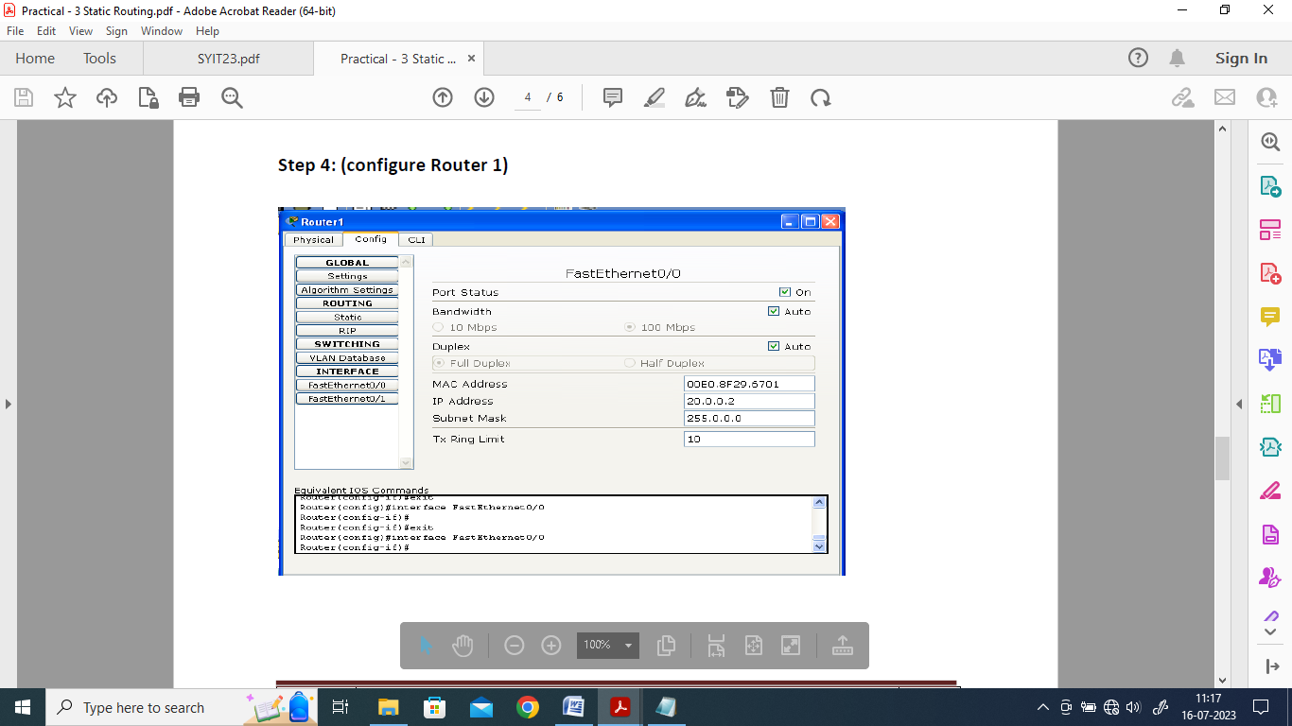

Interface: FastEthernet0/1

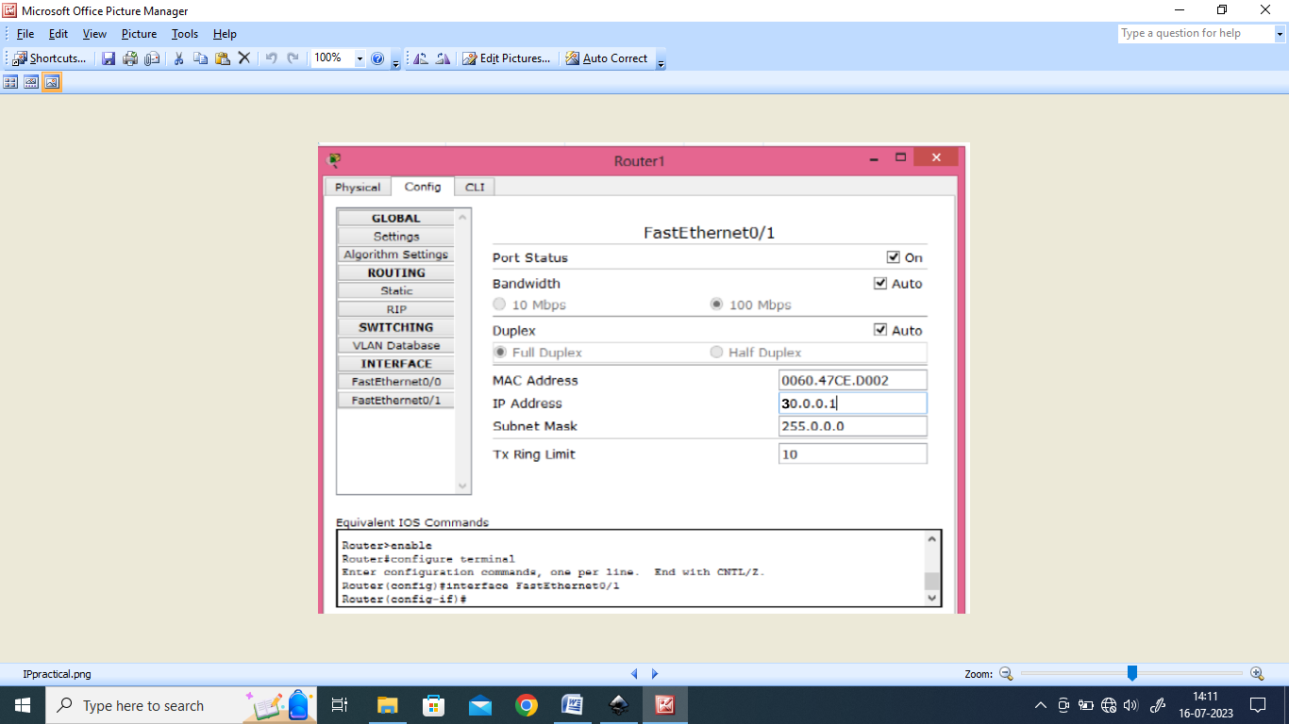

Step 5: Setting the Routing path in each Router through Static Routing

Step 5a) For Router 0

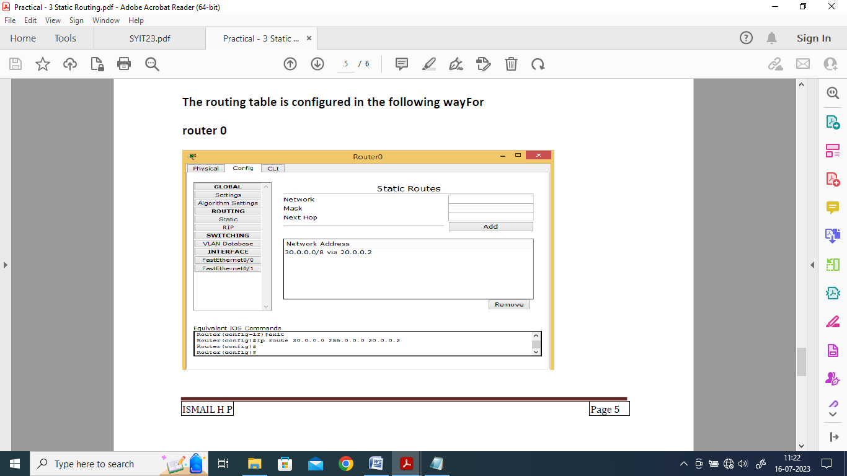

Step 5b) For Router 1

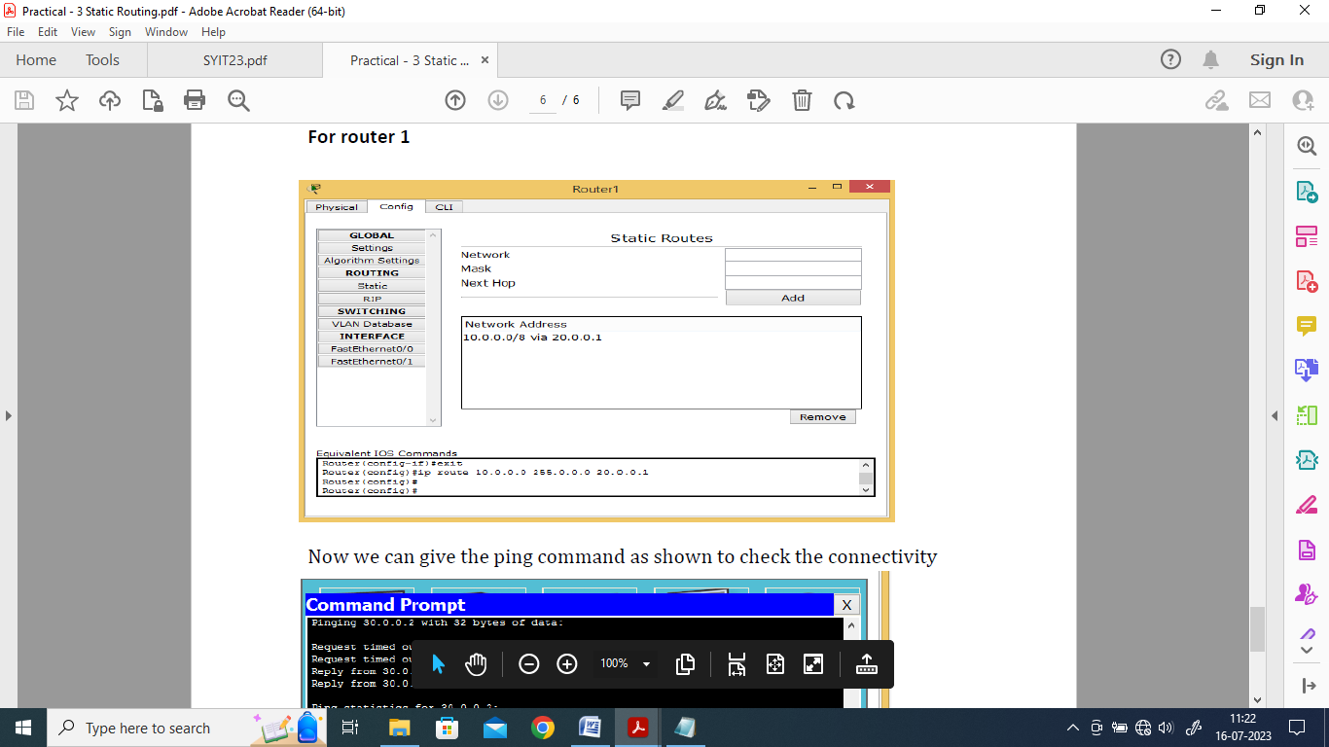

Step 6: Verifying the Connectivity using the Ping command

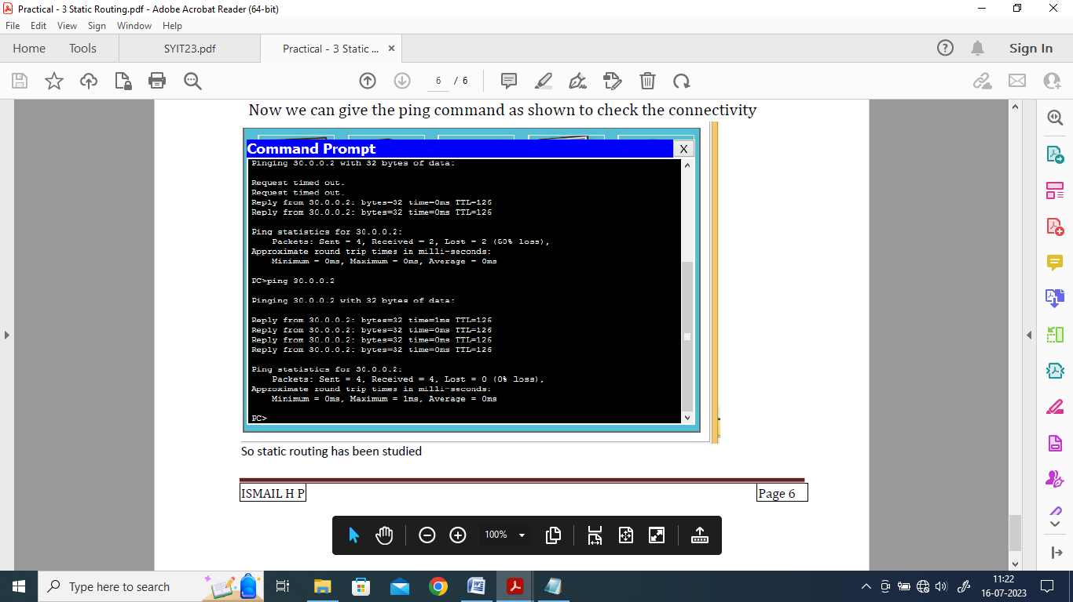

Hence static routing has been studied

| For Video demonstration of the given Practical, scan the QR code |  |
| --- | --- |